

Hypermedia Applications Project

IDM C/L/P Design Document

5/8/2016

Politecnico di Milano 5th School of Engineering

Contents

**IDM C/L/P D**esign **D**ocument 1

1. Purpose 3

2. Brief introduction 3

3. Conceptual design (C-IDM) 3

4. Logical Design (L-IDM) 5

5. Page design (P-IDM) 7

6. Interactive Mockup 9

7. Used tools 17

8. Working Hours 17

# Purpose

This document aims to describe the design and prototyping steps taken for implementing the web site for a large telecom company selling telecommunication infrastructures, devices and services assigned as part of a project of the “Hypermedia Applications (Web and Multimedia)” course at Politecnico di Milano.

# Brief introduction

The document provides detailed web application design procedure. Starting from the conceptual design, following up with logical design and, finally, page design. After page design is introduced, it is going to serve as the basis for interactive mock-up development and will be described at the end of this document. Explanation of all the symbols used can be found in the course's lesson slides.

# Conceptual design (C-IDM)

Conceptual design is made with respect to the specifications published in the reference document “Design Project Specifications” that was provided by professor. Short outline:

**SINGLE TOPICS**

1. WHO WE ARE

2. THE GROUP

**MULTIPLE TOPICS**

1. Device [10-100]

2. Smart Life (SL) Service [10-50]

3. Assistance Service [50]

**RELATIONSHIPS**

1. Available SL Service: Device →SL service [1, 5]

2. For device(s)_1: SL Service →Device [1-30]

3. Assistance for: Device →Assistance service [1, 10]

4. For device(s)_2: Assistance Service →Device [1-10]

**MULTIPLE GROUPS**

1. DEVICES BY CATEGORY[5]

2. SMART LIFE SERVICES BY CATEGORY [4]

3. ASSISTANCE SERVICES BY CATEGORY [4, N]

**GROUPS**

1. PROMOTIONS (for devices)

2. ALL DEVICES

3. ALL SL SERVICES

4. ALL ASSISTANCE SERVICES

5. HIGHLIGHTS

Following is the C-IDM diagram:

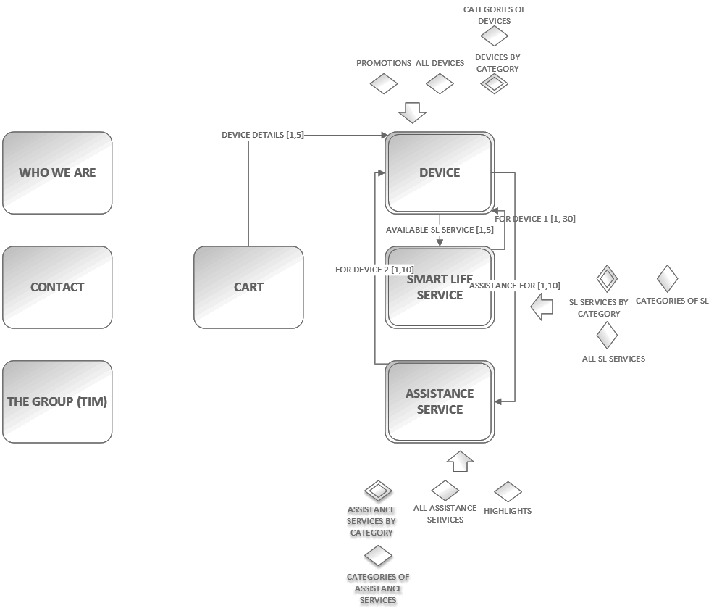

Figure 3.1 - Conceptual IDM schema

# Logical Design (L-IDM)

Logical design enhance C-IDM scheme by introducing content dialogue acts. Content dialogue acts can be perceived as Question and Answer form of interaction with the user. User asks the question about the content, and the system (web application) returns the contents that user asked for. Short outline:

**SINGLE TOPICS**

**1. WHO WE ARE**

• *Innovation*

• *Testimonials*

• *Projects*

**2. THE GROUP**

*• Group Description*

*• News*

*• Governance*

*• Business & Market*

*• For Investors*

**3. Device**

• *Presentation*

• *Technical Characteristics*

**4. Smart Life (SL) Service**

*• Description*

*• Activation and Rules*

*• (Optional) FAQ*

**5. Assistance Service**

• *Description*

Some other content dialogue acts were added to topics in order to completely describe them, like for example Device with image and description. We may pay attention to both, content dialogue acts which further describe our topics and multiple topics, in L-IDM schema (*fig 4.1.*), and to Relevant Relations that have cardinality value greater than one. Relevant relations that have cardinality equal to one are simple to implement, one simple link leading to other side of relation. The ones with cardinality greater than one require an additional transitional page in P-IDM schema. More about it in the next section. On the next figure L-IDM diagram is shown.

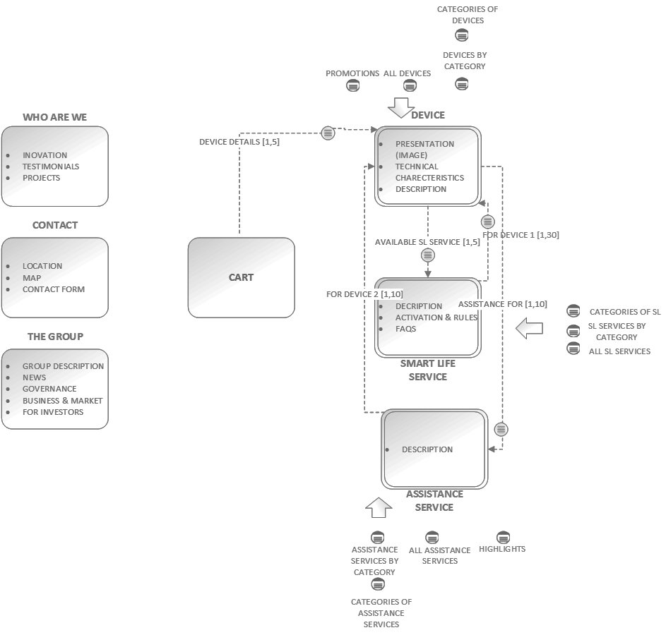

Figure 4.1 - Logical IDM schema

# Page design (P-IDM)

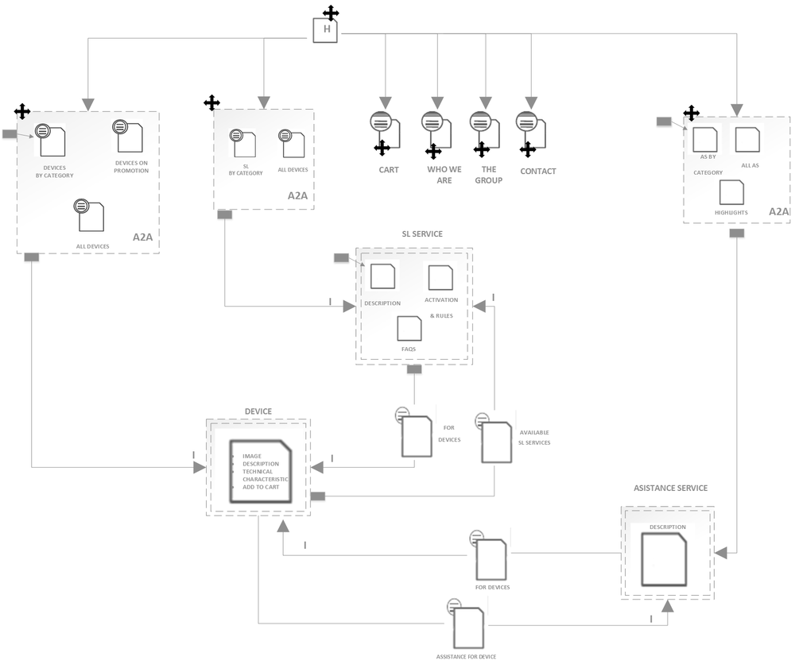

Figure 5.1 - Page IDM schema

In P-IDM our attention is focused on the implementation of our pages of web application. We need to convert entities from L-IDM schema to real html pages (at least to their high-level structures) and navigation links that will constitute our P-IDM schema. The cross symbol next to page represents that page is a landmark, that is, a page that is always accessible through navigation menu no matter on which page we are positioned. For simple pages on the right there is not much to say, but some pages on the left require a more thorough explanation.

For example, a group of pages on the leftmost side in a dashed rectangle are also a landmark. Once user clicks on that landmark he lands on the default page “*All courses by category*”, as it is denoted by the pointing arrow. That page is a transition page which shows all categories and their respective courses. The user can click on some of the categories and he will be navigated to page “*Category*” where he can get more information about the concrete category and instructors that teach courses for that category. Concrete instructor can be reached from that page or from landmarked transitional page “*All instructors*”. This dashed group has the A2A pattern, which means that all pages in a group are connected by navigational links among each other.

Testimonials are represented as a regular Topic page, except that they have navigational pattern “Guided tour” implemented for scrolling among concrete testimonials.

(Concrete) Rooms are also represented as a Topic page, and in addition they are fully connected among each other (A2A). Each concrete room page is accessible from any other.

Somebody may ask why there are single pages in a dashed group (e.g. Course, Category, Instructor, and Room). Those are pages that have cardinality greater than one, implying that there are multiple pages of the same type grouped in our rectangle.

Observing navigational arrows, we can notice that some of them are unidirectional and some of them are bidirectional. The bidirectional link provides us the possibility to return back to the page from where we came.

# Interactive Mockup

As the last step in the design process, we derive an interactive mockup from P-IDM (*fig 5.1.*) keeping in mind the goals of our proverbial contractors, owners of Big Gym (promotion and conveying information clearly) and that of our end-users, Big Gym's clients (getting all their questions answered). For the sake of readability all images will be a smaller than original size. You can, however, find a full interactive mockup in html format in the " *.MOCKUP/HTML/"* subdirectory.

Starting with the *Home Page* (fig 6.1), right below the web application's title is a navigation bar incorporating all landmark pages stated in P-IDM as navigation links. The same navigation element is used across all pages, and as such won't be mentioned in the sections that follow. Along with some descriptive elements like "*A different place*" and "*Our History*", *Home Page* also contains links "*Request more info*" and "*For a detailed layout click here*" which serve the user a popup contact form with optional newsletter subscription (*fig 6.2* ) and the *Rooms Page* (*fig 6.3*) respectively.

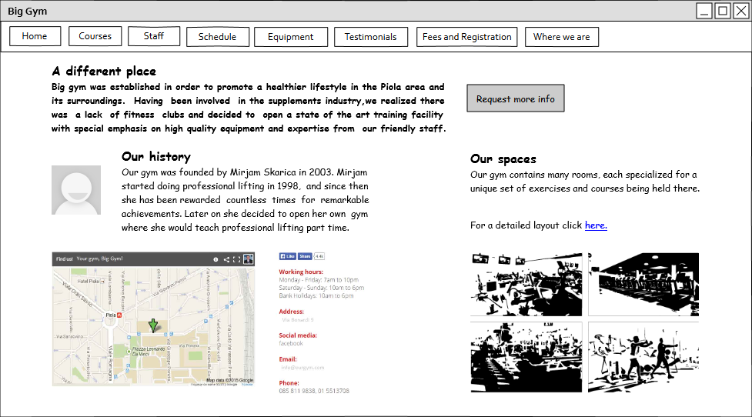

Figure 6.1 Home Page

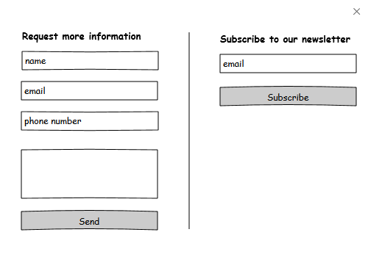

Figure 6.2 Request more information popup

*Rooms Pag*e, even though not a landmark, remains reachable from *Home Page* and individual *Course Pages.* To improve user's experience navigating our web application, we chose to implement a flavour of the popular breadcrumb element which is essentially a type of secondary navigation scheme. From *fig 6.3* we can see the element in the leftmost corner reading "*Home > Rooms"* informing the user from which page he navigated here. This element is used in single *Course Page, Category Page and Instructor Page* and won't be explained there to keep repetitiveness to a minimum.

Keeping in mind *Rooms* conceptually are a set of pages (and thus shown as a multiple topic in P-IDM), we have made a somewhat different design choice in order to complement the increasingly more popular dynamic feel and flow of content. We try to achieve this by having not multiple, but one page containing information about all of the different rooms. To clarify further, the page *contains* all information, but only one room's content is *displayed* at a time. We used the all-to-all navigation pattern to implement this seamlessly. By selecting/switching through tabs ( namely *room A1, room A2, room A3* in the *fig 6.3)* a different room's content is rendered dynamically. Each *Room* contains a map with its location highlighted, a gallery of photos and links to particular *Courses* held there.

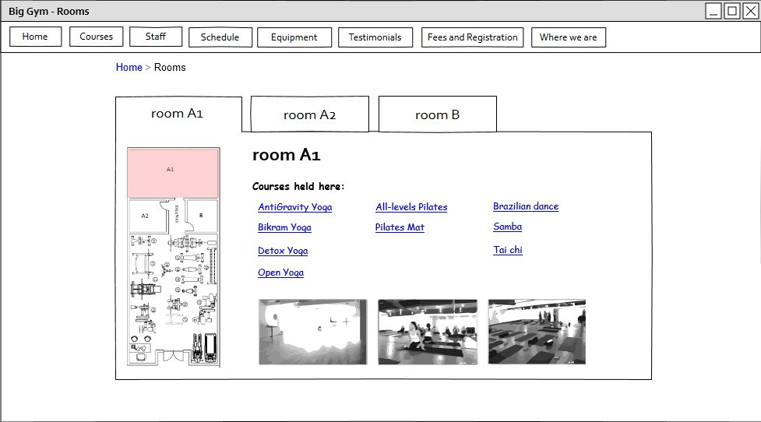

Figure 6.3 Rooms Page

*Staff Page*  (*fig 6.4*)denoted as *All instructors* in P-IDM is a page consisting only of transitional links. More specifically, each compound element, a picture and text below representing instructor's name, leads to a corresponding single *Instructor Page (fig 6.5)*.

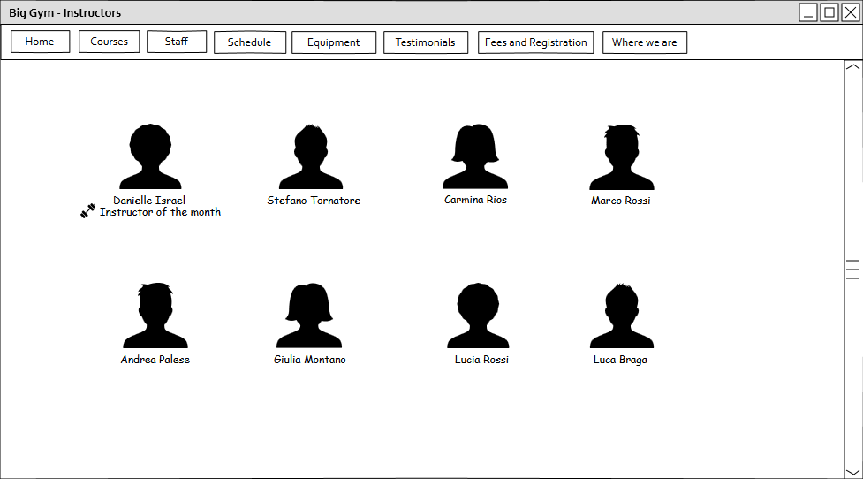

Figure 6.4 Staff Page

*Instructor Page* shown in *fig 6.5* is a page displaying specific instructor's name, bio, professional qualifications and awards. It also lists all the courses and corresponding categories the instructor teaches. Every list item is a transitional link which redirects the user upon click to a specific *Course (fig 6.8)* or *Category (fig 6.7)*. *Instructor Page* is reachable from either *Staff Page,* specific *Course* or *Category*.

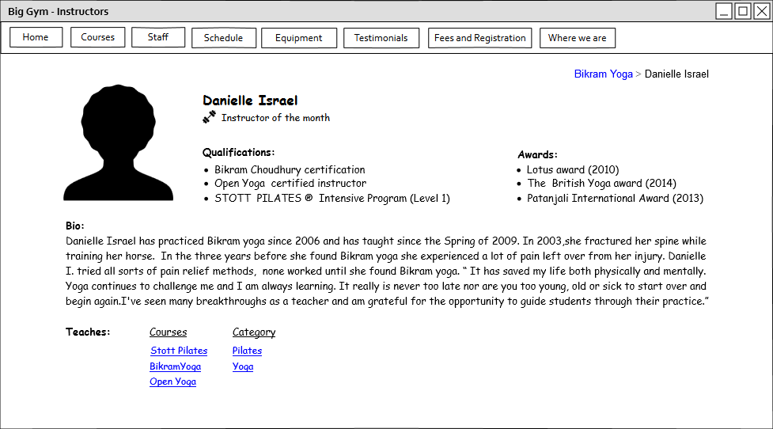

Figure 6.5 Instructor page

*Courses Page,* shown in *fig 6.6,* is a page heavily influenced and guided by the same dynamic content flow motivations argued in the *Rooms Page* paragraph*.* The rationale for *Courses Page* design choices follows. There is a finite set of specific single courses Big Gym is offering. Each course belongs to a category, level and, of course, has a name, meaning it intrinsically has a unique position in alphabetical ordering of all courses. That being said, it is easy to realize that the three pages of transitional links namely *Courses by category*, *Courses by level* and *Courses by alphabetical order* would basically have the *same* content (list of courses) just *visually* grouped and labeled differently. This is why we decided to merge the three pages into a single one practically. Conceptually though, they behave as 3 separate entities connected via all-to-all navigation pattern implemented as 3 tabs. All tabs behave in a similar way. They render labeled boxes (e.g. *Cardio* and *Dance* for Category, *Beginner* and *Intermediate* for Level and *A,B* for Alphabetical ordering) and in them a list of links redirecting user to a specific course (*fig 6.8*) upon click. The only tab that provides a piece of additional information is the *Category* one. Next to each label there is a link in shape of a circled *"i"* which redirects user to a specific *Category Page(fig 6.7*).

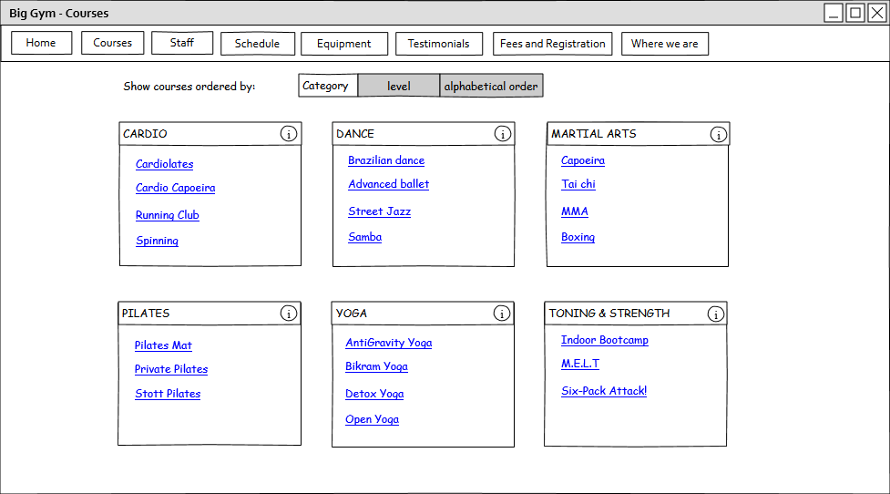

Figure 6.6 Courses Page

*Category Page* (*fig 6.7)* is reachable from the *Courses Pag*e (*Category* tab), specific *Instructor Page* and specific *Course Page.* It consists of simple text elements providing some general information about it's origins and benefits. Moreover, it has the following links. One for listing all courses of that specific category which redirects user to *Courses Pag*e (*Category* tab).Others for listing all instructors which teach at least one course of that category. Clicking on an instructor link serves the user the intructor's page (*fig 6.5*).

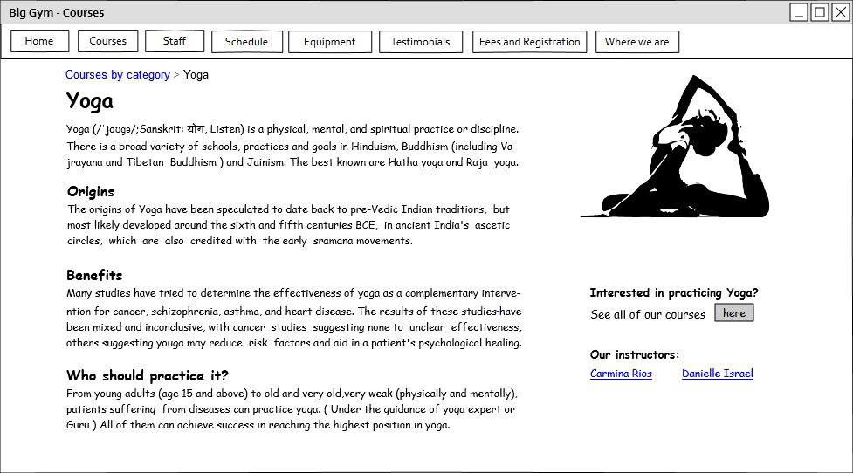

Figure 6.7 Category Page

*Course Page* shown in *fig 6.8* is a page providing information about the length of the course, expectations and schedule. It also provides information about its category, about which rooms it takes place in and which instructors teach it; all this in the form of links. Additionally it has a form through which users can quickly and simply enroll in the course. *Course Page* is reachable from either *Instructor Page, Courses Page,* specific *Category* or *Room page*.

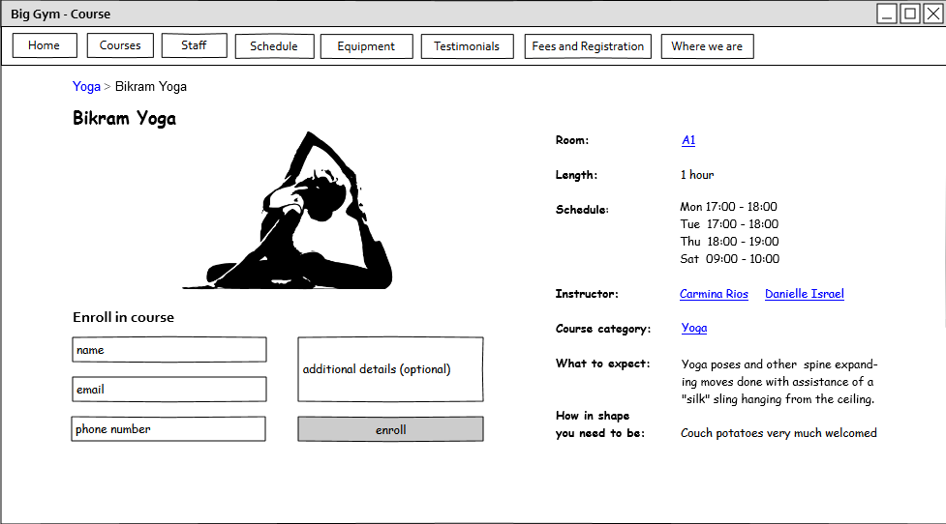

Figure 6.8 Course Page

Testimonials Page (*fig 6.9*) is a page consisting of 4 video reviews alongside some information explaining what can be expected from the videos which are made navigable using the guided tour pattern.  
  
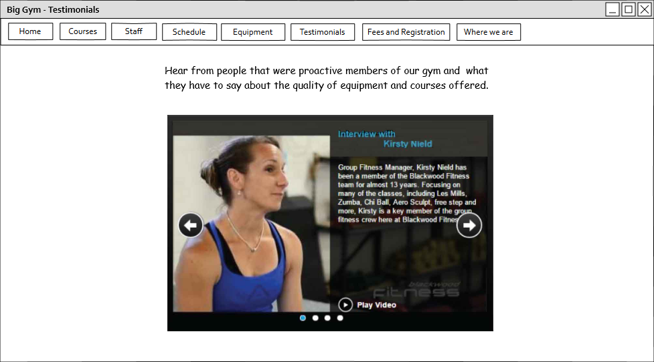

Figure 6.9 Testimonials Page

Part from the fact *Location Page* and *Fees and Registration Page* embed contact and registration forms, respectively, *figures 6.10-6.13* are not in need of extensive descriptions as they don't utilize any specific navigational patterns, nor were any specific design decisions made. They are included in this document for completeness.

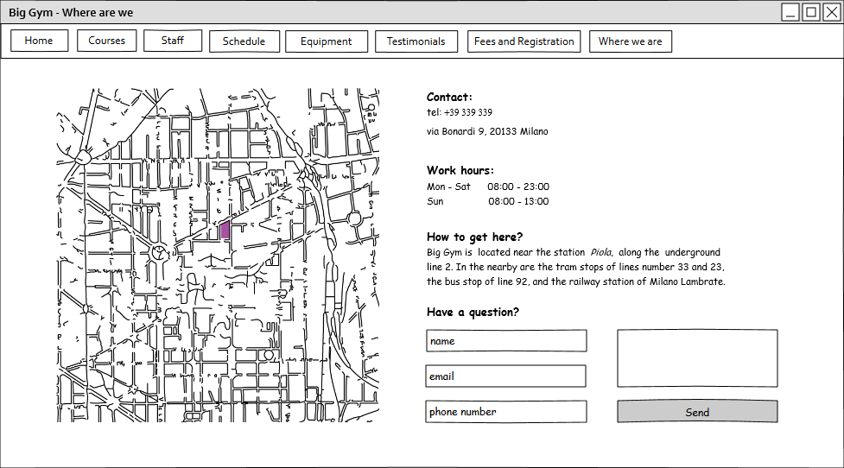

Figure 6.10 Location Page

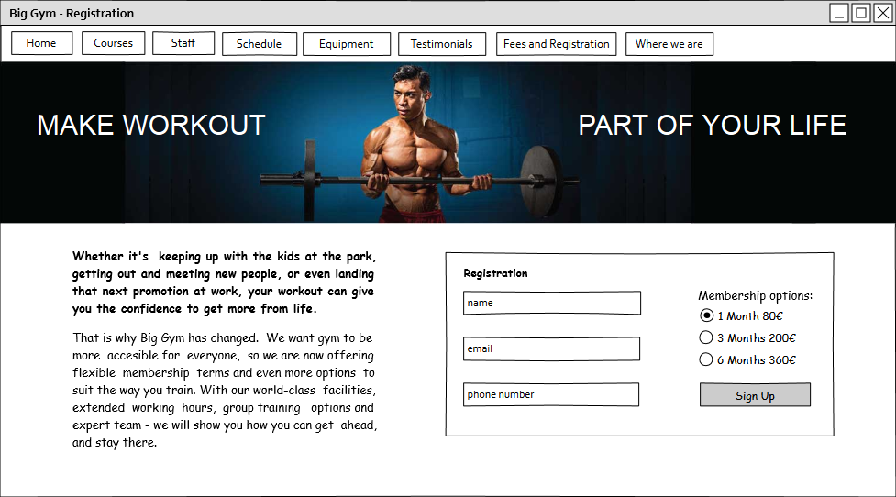

Figure 6.11 Fees and Registration Page

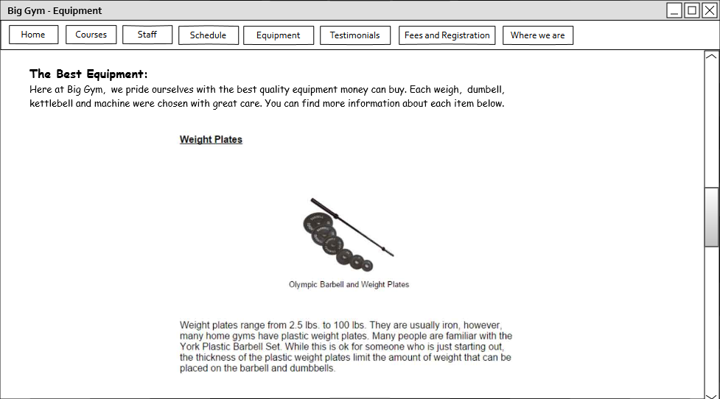

Figure 6.12 Equipment Page

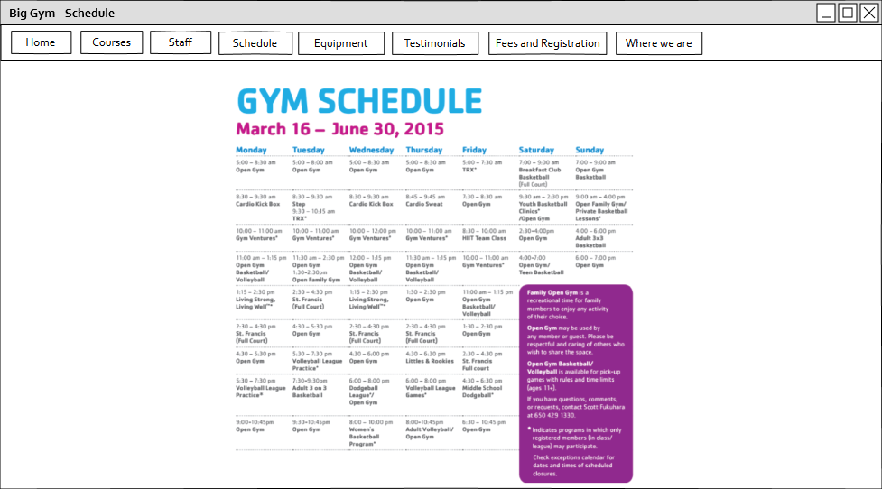

Figure 6.14 Schedule Page

# Used tools

* Microsoft Office Word
* Adobe Illustrator
* Evolus Pencil

# Working Hours

|  |  |
| --- | --- |
| **Name** | **Working hours** |
| NemanjaStolic | 20 hours |
| MirjamSkarica | 20 hours |